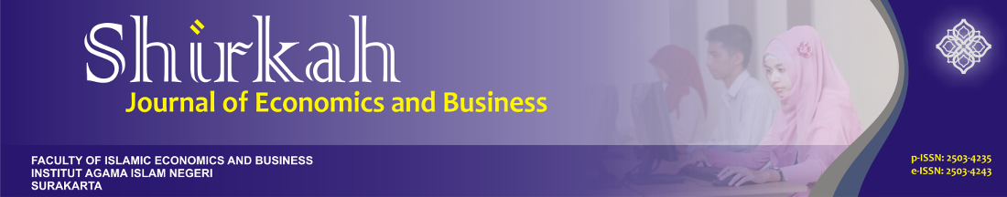

**Cover Letter & Declaration Form**

**Submission Title : What Drives *Muzakki* to Pay *Zakah* at the Baitul Mal of Banda Aceh City, Indonesia**

**Author(s) : Fathin Azzahra and M. Shabri Abd. Majid**

**Contact e-mail : mshabri@unsyiah.ac.id**

**Telp : 082160229553**

Dear Editor in Chief,

*Shirkah Journal of Economics and Business*

As a corresponding author, I declare that the submitted paper is my original research work. I am submitting this manuscript for publication in *Shirkah Journal of Economics and Business*. This manuscript has not been previously published and is not currently under review elsewhere. I will not withdraw my manuscript while the review process is in progress.

I have properly cited the works of others in the text as well as in the reference list. I accept all the terms and conditions displayed in “publication ethics” <http://shirkah.or.id/new-ojs/index.php/home/index> to the best of my knowledge.

I have confidently checked the paper out of plagiarism using Turnitin Plagiarism Checker as being detected of equal to 13 % potential similarity.

Signature:  Date: 8 March 2020

**Ps: please enclose this scanned file along with the submitted manuscript,**

**or separately send it through** [**shirkahiainsurakarta@gmail.com**](mailto:shirkahiainsurakarta@gmail.com)

**Publisher Info: Journal Info:**

**Australian International Academic Centre PTY. LTD. Website: http://www.alls.aiac.org.au**

**11 Souter Crescent, Footscray VIC 3011 E-mail: editor.alls@aiac.org.au**

**Australia**

**Website: http://www.aiac.org.au**

**You are kindly requested to fill in this form, sign, and return it to the editor via E-mail.**

**Publisher Info: Journal Info:**

**Australian International Academic Centre PTY. LTD. Website: http://www.alls.aiac.org.au**

**11 Souter Crescent, Footscray VIC 3011 E-mail: editor.alls@aiac.org.au**

**Australia**

**Website: http://www.aiac.org.au**

**Publisher:** Jln. Pandawa, Pucangan, Kartasura

Faculty of Islamic Economics and Business Central Java, Indonesia

IAIN Surakarta shirkahiainsurakarta@gmail.com